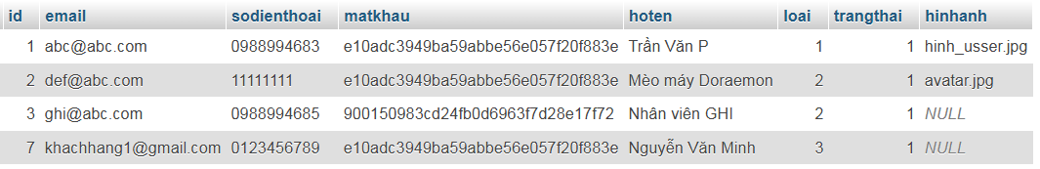

* **Trang admin**:
* Username: [abc@abc.com](mailto:abc@abc.com)
* Password: 123456
* **Trang bán hàng dành cho khách hàng**
* Username: [khachhang1@gmail.com](mailto:khachhang1@gmail.com)
* Password: 123456